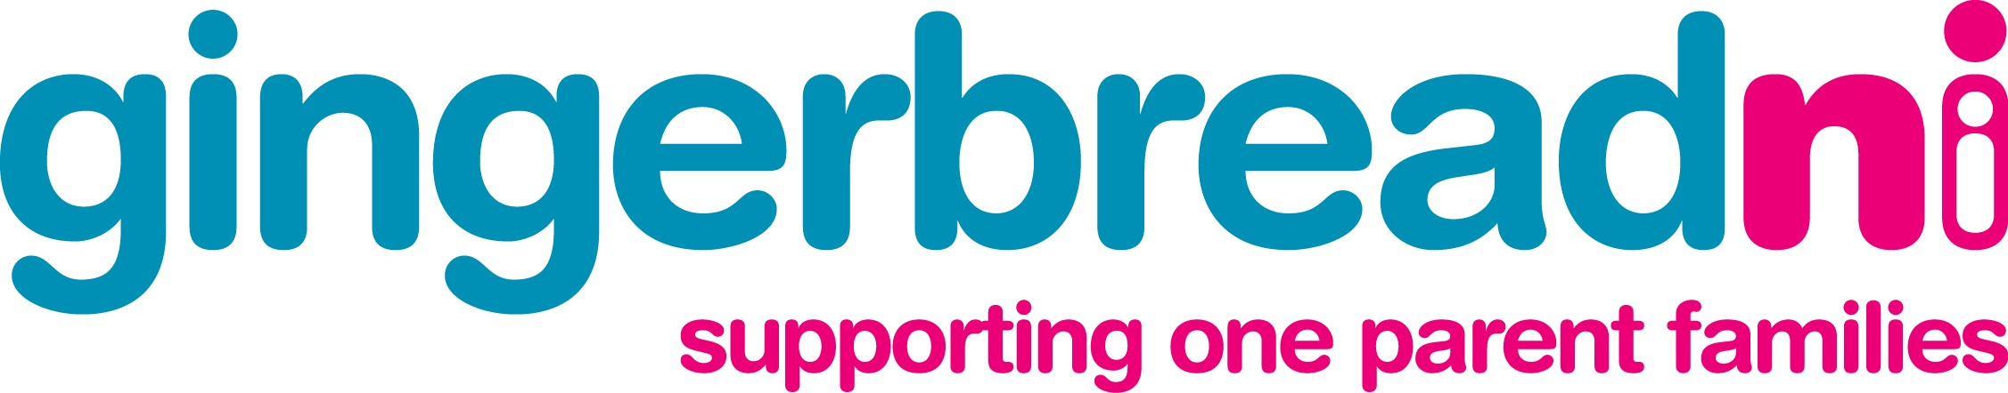

DATE: 22nd November 2007

Press Release

Partnership brings new ‘Possibilities’ for lone parents

Lone parent support organisation, Gingerbread Northern Ireland, has published a report examining the realities facing lone parents returning to employment. ‘Equality of opportunity for lone parents – creating positive change through partnership’ was launched at Stormont during an event hosted by Sir Reg Empey, Minister for Employment and Learning.

The report was produced by the ‘Possibilities’ Partnership, which includes Gingerbread NI, the Department for Employment and Learning (DEL), the University of Ulster (UU) and employment matching service, Gems NI, The organisations worked together over the past few years to research the barriers to employment that lone parents face.

The report contains research findings carried out by the University of Ulster, which confirms that 92,000 families in Northern Ireland are now headed by a lone parent. The report reveals that while many lone parents here want to work, they often face more difficulty in finding and remaining in employment than their counterparts in Britain.

Dr Ann Marie Gray of UU explains:

‘We know that many lone parents in Northern Ireland want to work but they face disadvantage in the labour market due to lack of suitable qualifications and childcare. We need to make sure that they have access to appropriate advice, training and support to allow them to find sustainable jobs, which will provide long-term security for their families. Lone Parent families have also been disadvantaged by the lack of an integrated childcare strategy and this needs to be urgently addressed’

The partners were also involved in piloting an innovative training approach to supporting lone parents interested in returning to work. ‘Possibilities’ Project Co-ordinator, Karen McCann comments on the value of doing this in partnership:

‘‘Working in partnership, we provided a package of support services including life coaching, skills training and advice. Lone parents taking part also had access to childcare and work tasters with local employers. This model proved so successful that this help is now being made available through the mainstream Pathways to Work for Lone Parents programme which we provide in partnership with DEL..’

‘Possibilities’ was developed as part of the EU EQUAL initiative, a Europe-wide programme which tests new ways of tackling discrimination and inequality experienced by those in work and those looking for a job. The project attracted interest from other countries with a number of delegates from other EU countries in attendance. Speaking at the launch, Anne Sweeney, Assistant Director of Gingerbread Northern Ireland said:

‘Increasingly work is being seen as the best route out of poverty for lone parents so it is essential that we know about barriers preventing them from having equality of opportunity when it comes to getting a job. Gingerbread will use the findings of this project to influence policy to create greater equality of opportunity for lone parents who choose to work.’

The event was attended by over one hundred key policy makers from the public and voluntary sectors including MLA’s and senior representatives from a number of government departments. The event also attracted interest from other European countries
ENDS

Notes to Editor:

-There are 92,000 one parent families in Northern Ireland
-One in four families with children is a one parent family
-One parent families are twice as likely to be poor as two parent families
-Research was carried out with 82 lone parents from throughout Northern Ireland. 77% of lone parents surveyed say that they want to work outside the home at some point
-The report and an executive summary are available from www.gingerbreadni.org

Opportunities for photographs and interviews available at the Long Gallery, Parliament Buildings at 10.30am on Thursday 22nd November, 2007.

For more information contact:

Maria Curry
Gingerbread NI
Contact: 07876583698

