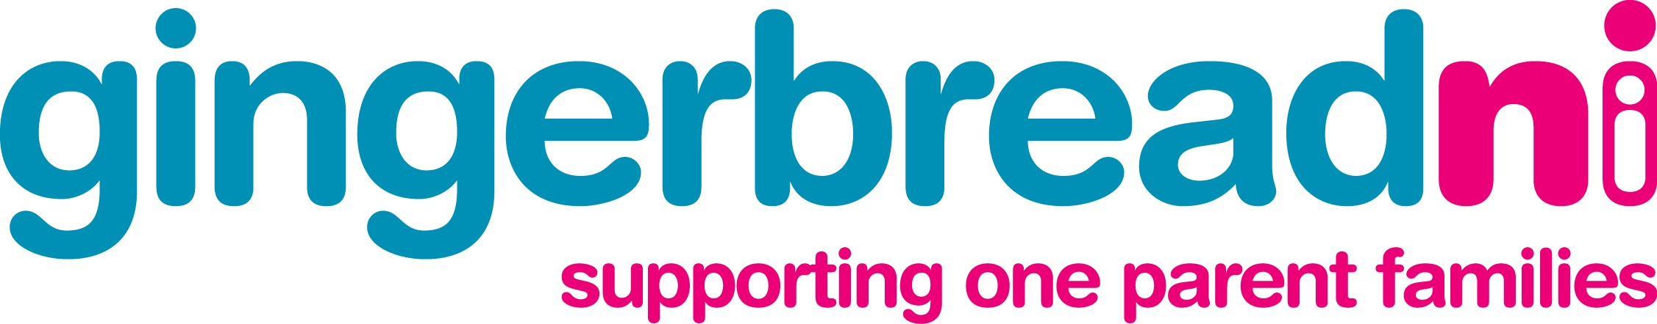

Press Release

Date: 29th April 2009

Embargoed: 30th April 2009

Information for All

Gingerbread launches leaflets for lone parents from minority ethnic communities

Gingerbread NI, the organisation supporting one parent families has chosen, the lead into Polish Cultural Week, 07 – 13 May 2009, to launch a series of information leaflets in seven languages aimed at lone parents from minority ethnic communities residing in the Southern Area. The leaflets, produced with support from the Southern Area Children and Young People’s Committee, are available in Lithuanian, Polish, Portuguese, Tetum, Russian, Slovakian and Romanian.

Director of Gingerbread, Marie Cavanagh explains,

“We have become aware of growing numbers of lone parents from other countries who are settling in the area and we want to ensure that they have access to support. We recognise that some may still be learning English so we have made our materials available in some of their own languages. Life as a lone parent can be difficult enough without having to deal with a language barrier and lone parents, like all parents, want the best for their families. Gingerbread aims to help them by giving them access to the services that are out there”

Speaking on behalf of the project funder, Ann Godfrey, Children’s Services Planner with the Southern Area Children and Young People's Committee welcomed the development,

“The Committee is very pleased to be able to support the production of these new materials which will enable Gingerbread to make its services more accessible to lone parents from overseas who come to this area”

Edel Fox, from South Tyrone Empowerment Programme (S.T.E.P) who worked closely with Gingerbread in the production of these leaflets said,

“Through our work we understand that being a lone parent and arriving in Northern Ireland is not easy. Even if you speak English, it is hard to understand the law and your entitlements, to know your rights and to be able to stand up for yourself and your family. Gingerbread offers unique services designed for lone parents and Gingerbread is making a positive step in addressing the current needs by providing information, which is available to every lone parent, despite the barrier of language. We welcome the creation of these leaflets as it will increase awareness of what services are available and accessible to lone parents from all backgrounds”

The launch of the leaflets took place in St Patrick’s Trian Armagh and leaflets are available through various agencies working with minority ethnic groups in Northern Ireland or by contacting Gingerbread NI on 028 9023 1417 or online www.gingerbreadni.org.

Ends

Notes for Editors:
1. The launch of information leaflets takes place on Thursday 30th April 09@10.45am to 12 noon in The Robinson Room, Saint Patrick’s Trian, 40 English Street, Armagh BT61 7BA.

2. Gingerbread NI is the lone parent, membership-led organisation, supporting one-parent families in Northern Ireland to improve their lives and the lives of their children. Gingerbread develops and delivers services to one-parent families through its centres in Belfast, Ballymena and Derry. These services include family support services through;

- Advice and information
- Children and young people’s services, including direct childcare and play provision
- Vocational training
- Membership services
- Research to identify the needs of one parent families

3. The Southern Area Children and Young People's Committee (SACYPC) was set up in 1998. The partnership began life as the statutory agencies which were named in the Guidance which set up Children's Services Planning. Since then, the partnership has developed both in terms of membership and joint commitment to the task of multi-agency planning of services for vulnerable children and young people. SACYPC now has a balanced membership across the statutory, voluntary and community sectors which either provide services for or are concerned with the lives of children and young people.

For further information contact:
Marie Cavanagh, Director Maria Curry, Membership Co-ordinator
W: 028 90231417 W: 028 90231417
M: 07711762525
E: marie@gingerbreadni.org E: mcurry@gingerbreadni.org

W: www.gingerbreadni.org W: www.gingerbreadni.org

