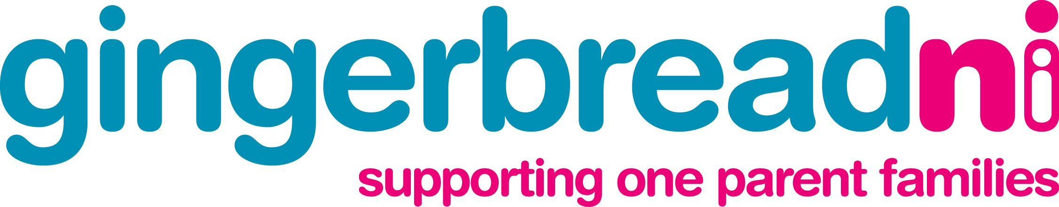

Press Release

Date: 30th November 2007

For Immediate Release:

Gingerbread’s launches an ‘Advice Pack’ for lone parents.

Gingerbread, the organisation supporting one parent families, which is based at Bayview Terrace in Derry has launched an ‘Advice Pack’ for lone parents to help guide lone parents and their children through many of the difficult issues that they face.

The pack was launched today at an event in the City Hotel, Derry by the Mayor, Drew Thompson. The Advice pack is in a handy booklet format and covers a range if issues that affect one parent families including:

- Relationship Breakdown
- Child Support
- Coping with Benefits
- Children’s Rights
- Bereavement
- Going back to work or education
- Housing
- Tax Credits

Gingerbread hopes that the pack will act as a tool to help lone parents deal better with some of the challenges that they face so that they can be better placed to take up opportunities available to them to improve their family situation and provide for themselves and their children.

Eileen Curran, Gingerbread’s Advice and Information Officer commented:

“One parent families make up a quarter of families in the North West and face a range of barriers that hold them back. Lone parents, like all parents, want the best for their families and Gingerbread aims to help them do that. We provide practical assistance and promote self help – this Advice Pack, with the back up of Gingerbread’s Advice and other services aims to give lone parents all the information they need to help them make informed choices that will help them better themselves and give one parent families an equal chance”

To get a copy of the Advice Pack, call Gingerbread’s Freephone Advice Helpline on 0808 808 8090 to speak to an Advisor or call in to Gingerbread’s Western Area office at 7, Bayview Terrace.
Ends

Notes for Editors:
For further information contact:

Eileen Curran - Advice and Information Officer, Gingerbread:

T: 7137 7066

E: eileen@gingerbreadni.org

Gingerbread’s Advice Service offers a free, confidential and impartial service to one parent families as well as Childcare, Careers Guidance and Training.

Research conducted by Gingerbread NI and University of Ulster into one parent families in the Western Health Board Area (‘Bright Futures?’ report, 2005) revealed :

- 90% of lone parents wish to work outside of the home at some stage
- The average age of lone parents is 35, less than 3% of lone parents are teenagers
- 46% become lone parents due to separation or divorce
- 81% of lone parents cited money worries a source of stress
- 75% of all lone parents surveyed where in debt
- 18% were in debt with heating/lighting bills
- 67% live in rented accommodation

