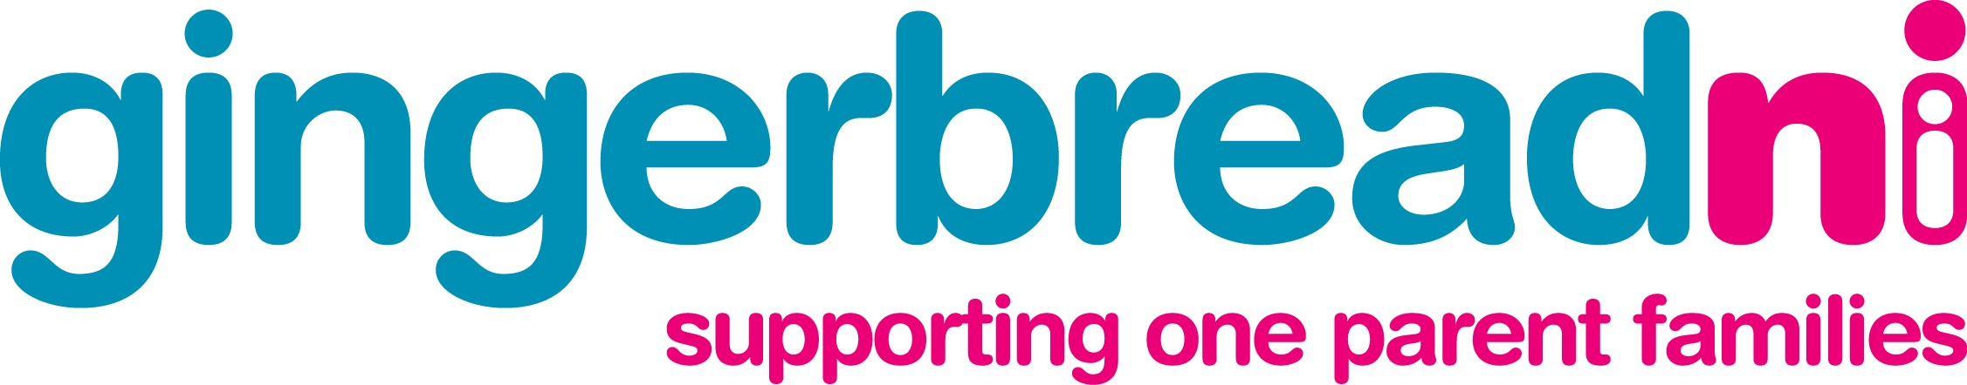

Press Release

For Immediate Release: 30th October 2008

Gingerbread’s launches an ‘Advice Pack’ for lone parents.

Gingerbread, the organisation supporting one parent families, which is based at Greenvale Street in Ballymena has launched an ‘Advice Pack’ for lone parents in the Northern Health and Social Services Board area. The aim of the Advice Pack is to help guide lone parents through many of the difficult issues that they face so they overcome many of the barriers that they face.

The pack is funded by the Children and Young People’s Committee of the Northern Health and Social Services Board and was launched today at an event in The Braid – Ballymena Town Hall, by the Mayor of Ballymena, Councillor Maurice Mills. The Advice Pack is in a handy booklet format and covers a range of issues that affect one parent families including:

- Relationship Breakdown
- Going back to work
- Child Maintenance
- Child Trust Fund
- Tax Credits
- Children’s Rights
- Benefits
- Bereavement
- Housing

Gingerbread hopes that the pack will act as a tool to help lone parents deal better with some of the challenges that they face so that they can be better placed to take up opportunities available to them to improve their family situation and provide for themselves and their children.

Seán Ó Néill, Gingerbread’s Advice Service Manager commented:

“One parent families make up a quarter of families in the Northern Health Board area and often face a range of barriers that hold them back including poverty, difficulty accessing childcare and a lack of co-ordinated services. Research shows that 90% of lone parents want to work outside the home at some stage - lone parents, like all parents, want the best for their families and Gingerbread aims to help.

We provide practical assistance and promote self help – this Advice Pack, with the back up of Gingerbread’s Freephone Advice Helpline, website and other services aims to give lone parents all the information they need to help them make informed choices that will help lone parents better themselves so that one parent families can have an equal chance.”

Speaking at the launch, Mr Kevin Keenan, Director, Social Services and Chair of the Northern Area Children and Young People's Committee congratulated Gingerbread on the production of their Advice Pack. He said:

"This pack will help to provide lone parents with accurate, up to date and timely information about how to access a range of services. I am delighted that the Children and Young People's Committee of the Northern Board has been able to fund this valuable resource which will help to support lone parents living in the Northern Board area."

To get a copy of the Advice Pack, call Gingerbread’s Freephone Advice Helpline on 0808 808 8090, call in to Gingerbread’s office at 5a Greenvale Street, send an email to : advice@gingerbreadni.org or go to www.gingerbreadni.org

Ends

Notes:
For further information contact:

Seán Ó Néill, Advice Service Manager, Gingerbread NI

T: 9023 1417 E: sean@gingerbreadni.org

Gingerbread’s Advice Service offers a free, confidential and impartial service to one parent families as well as Childcare, Careers Guidance and Training courses for lone parents.

Research conducted by Gingerbread NI and University of Ulster shows that:

- 90% of lone parents wish to work outside of the home at some stage
- The average age of lone parents is 35, less than 3% of lone parents are teenagers
- 46% become lone parents due to separation or divorce
- 81% of lone parents cited money worries a source of stress
- 75% of all lone parents surveyed where in debt
- 18% were in debt with heating/lighting bills

